1. non-TurboJET Product

if getProductDetails no TurboJET object returned, this is a non-TurboJET Product

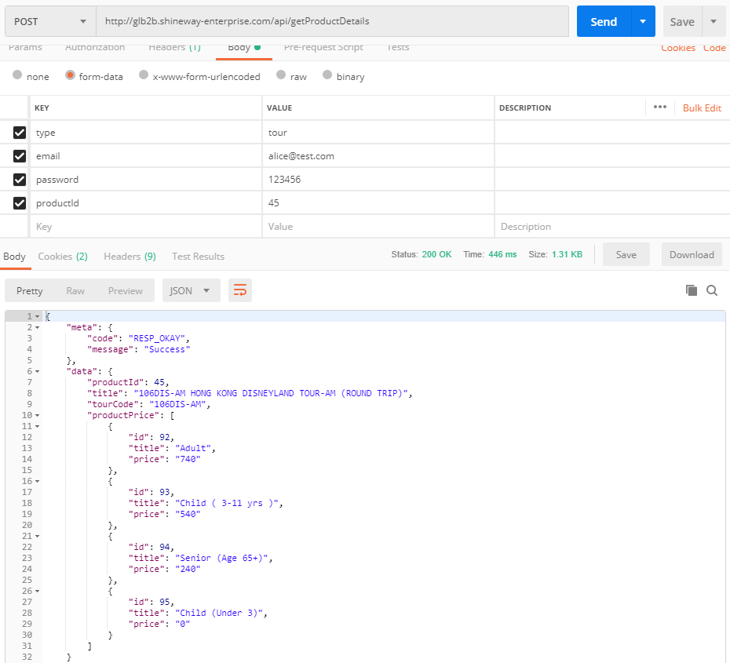

queryProduct result of non-TurboJET product:

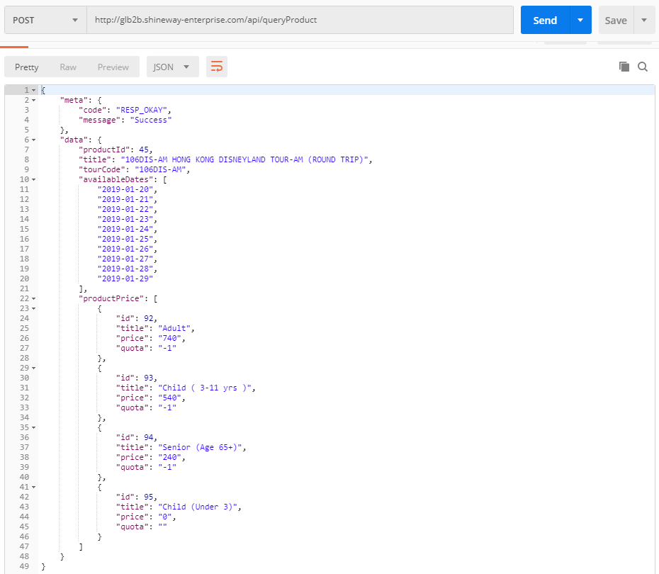

1. TurboJET product

if getProductDetails has TurboJET object returned, this is a TurboJET Product

1. If getProductDetails only return turbojet but no productPrice:

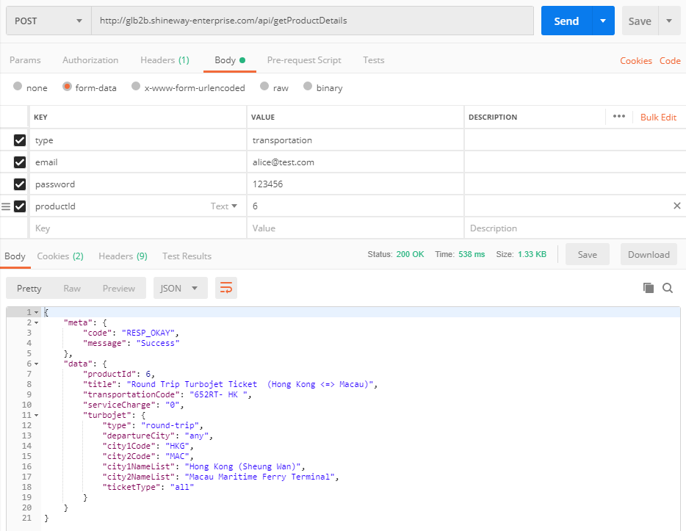

1. turbojetQuantity and turbojetClass are required when calling queryProduct
2. departureAvailableFlight / returnAvailableFlight will be returned

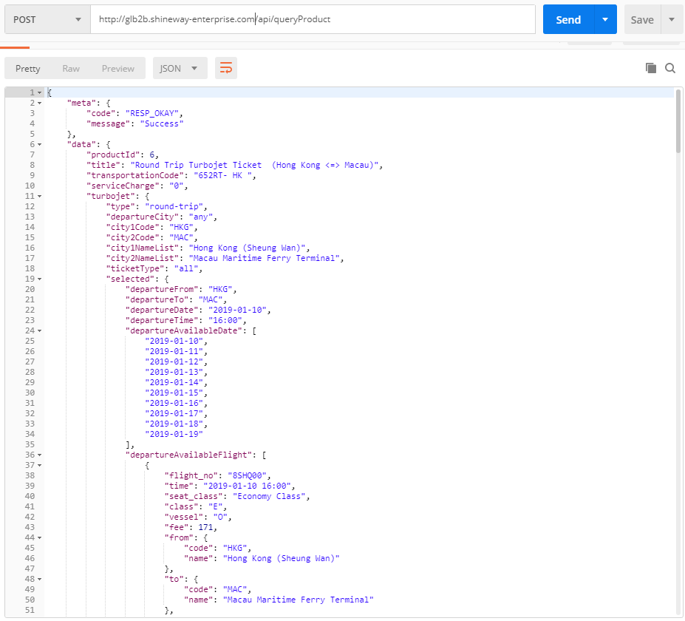

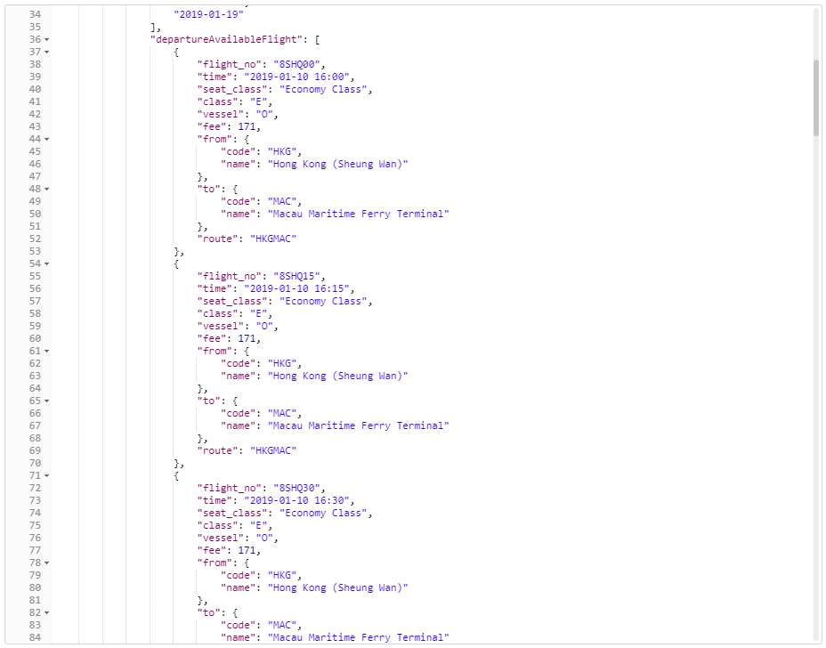

1. if getProductDetails return turbojet, productPrice and turbojet.productType, and turbojet.productType = ‘open-sailing’

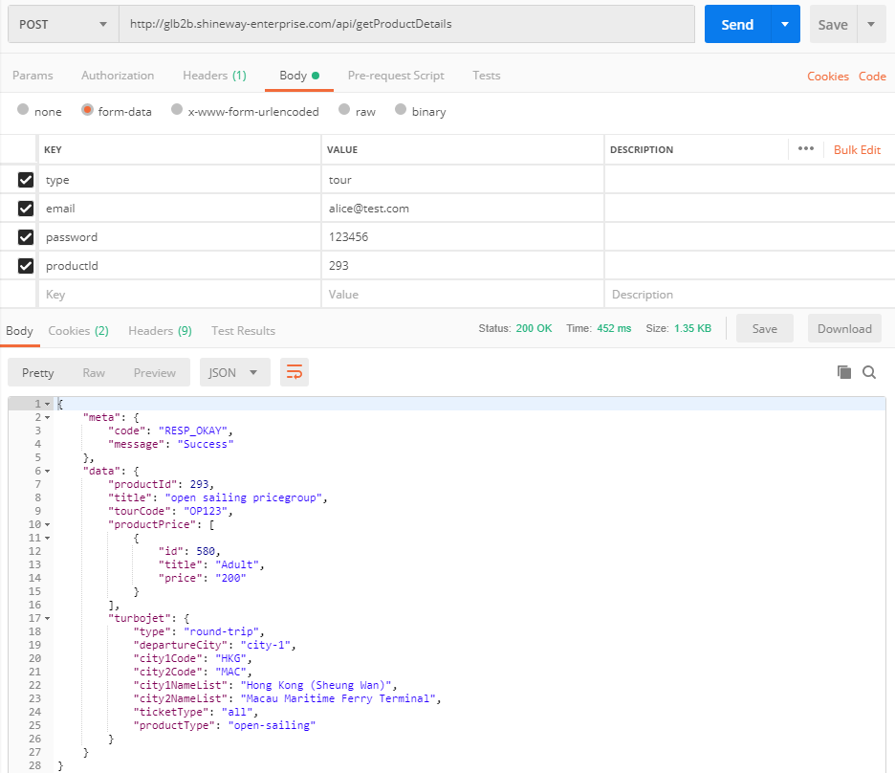

1. turbojetDepartureTime and turbojetReturnTime are not necessary when calling queryProduct
2. departureAvailableTime / returnAvailableTime will not be provided if turbojet productType = ‘open-sailing’

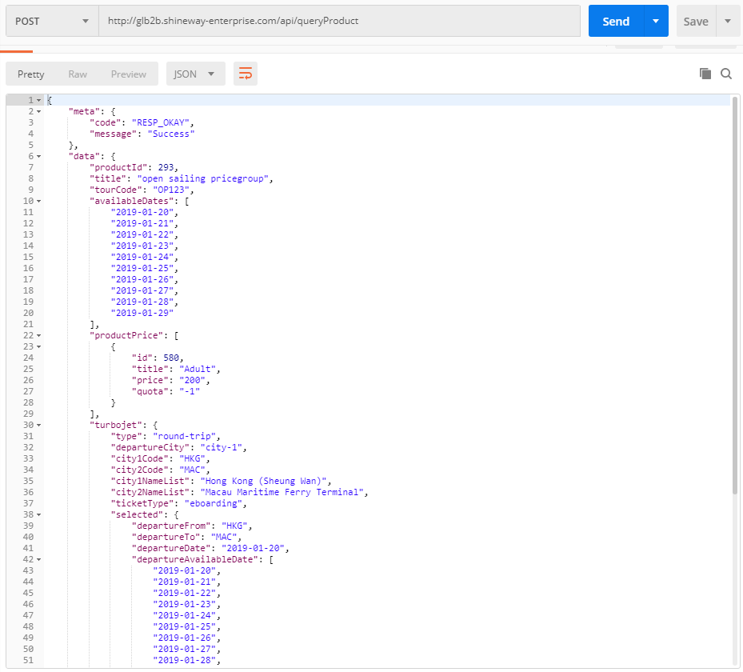

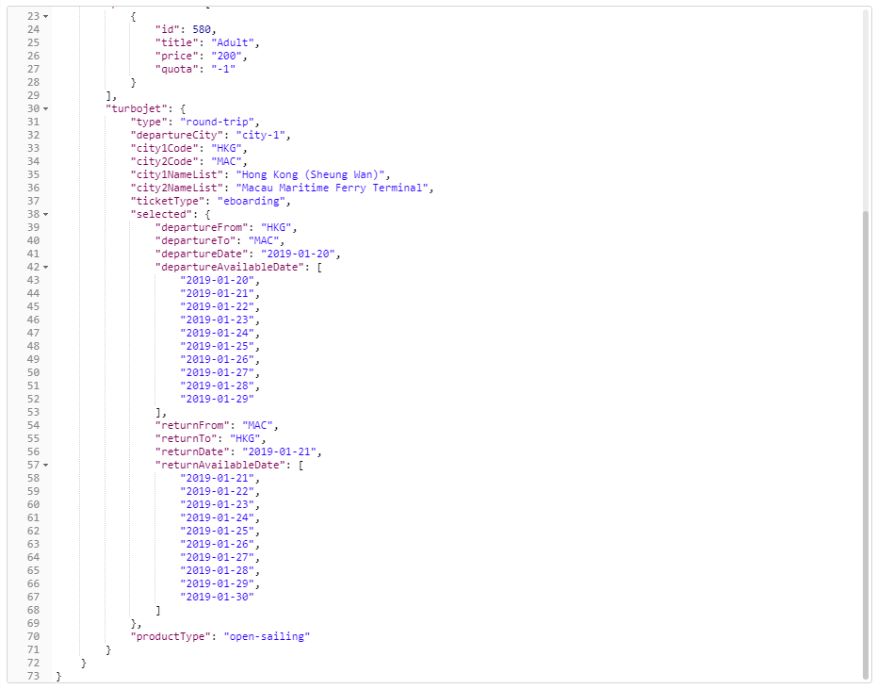

1. if getProductDetails return both turbojet and productPrice

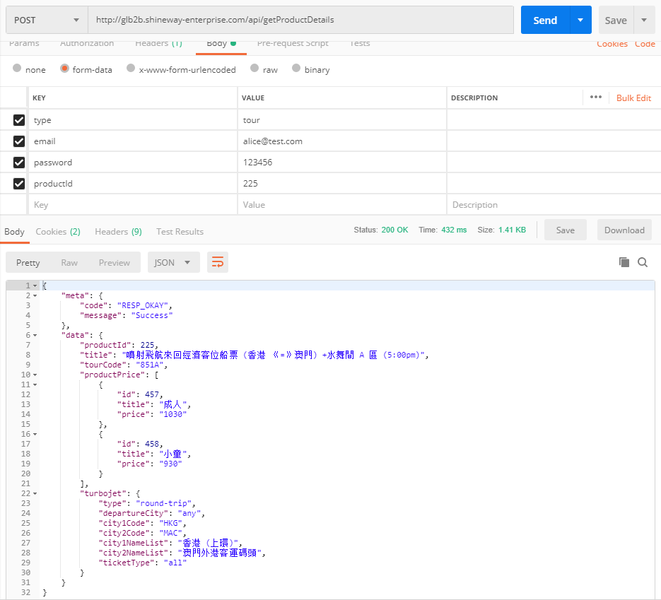

1. subQty is required when calling queryProduct
2. departureAvailableTime / returnAvailableTime will be returned

